Press release

ulrich medical is one of the first MDR-audited German medical technology manufacturers

ulrich medical passed the certification audit of TÜV Süd according to the new EU medical device regulation

Ulm, January 2020. From January 14 to 16, ulrich medical successfully underwent an MDR audit. This makes the family-owned company from Ulm one of the first medical technology manufacturers in Germany to be ready for the new European Medical Device Regulation (MDR, Regulation (EU) 2017/745), which will become mandatory in May 2020. In the course of the audit, carried out by the notified body, TÜV Süd, the conformity of ulrich medical’s company processes according to MDSAP was also reviewed. MDSAP (Medical Device Single Audit Program) standardizes audit guidelines for the USA, Japan, Canada, Australia, and Brazil. The three-day review period was completed by the additional successful auditing of the company's own quality management system according to ISO 13485:2016.

All European medical technology companies have internalized one deadline: May 26, 2020. As the three-year transition phase comes to an end, the new MDR will take full effect and be binding for all manufacturers. It replaces the former MDD (Medical Device Directive) EU regulation and initially affects all products that fall in Class I. All other medical technology products may be placed on the market under the existing MDD certification during the extended transition period until May 2024.

ulrich medical is one of the first companies to successfully face this major challenge for the medical technology industry. The changeover to the new regulation goes hand in hand with a significantly increased documentation effort and stricter test criteria compared to the old EU regulation, as well as the obligation to conduct clinical studies. These are all reasons why ulrich medical had set up an internal MDR competence team in 2017, which is dedicated to all aspects of the changeover process in ongoing operation across companies and has made a significant contribution to the now successfully completed audit process.

Security of supply is guaranteed
Large hospital operators and purchasing associations are unsure about the MDR. Many are wondering how small and medium-sized companies in the medical technology sector in particular will be able to cope with the increased regulatory requirements and the documentation effort involved. “For some time now, we’ve been receiving more and more customer inquiries whether we can guarantee delivery availability from May 2020. This question is indeed justified as the MDR presents a huge challenge. We are all the more pleased that we have done everything possible to pass the MDR certification audit,” reports Christoph Ulrich, managing partner at ulrich medical. “Thanks to the successful alignment of our processes according to MDR guidelines, we are once again living up to our positioning as a long-term reliable and international partner for end users and dealers alike. We don’t expect any negative effects on our ability to deliver.”

ulrich medical continues to provide information on all the latest MDR news on its website and social media channels.

Text length: 3,173 characters (including spaces)

About ulrich medical
ulrich medical has been developing, producing and distributing medical technology since its foundation as a family-owned company in 1912. Doctors and users from around the world rely on its more than 100 years of expertise. As one of the few companies in the industry to do so, the company from Ulm backs “Made in Germany” by developing and producing its products in Germany. Ulrich medical is a specialist in the product divisions of Spinal Systems and Contrast Media Injectors. The Spinal Systems division develops, produces and successfully distributes around the world implants that are predominantly made of titanium. They are used for injuries and diseases affecting the entire spine. In the field of Contrast Media Injectors for CT and MRI, ulrich medical offers specially developed user solutions that support radiologists with modern diagnostic imaging. Their user-friendly handling, outstanding quality and proven hygienic safety make them essential to everyday practice.

Image: ulrich medical
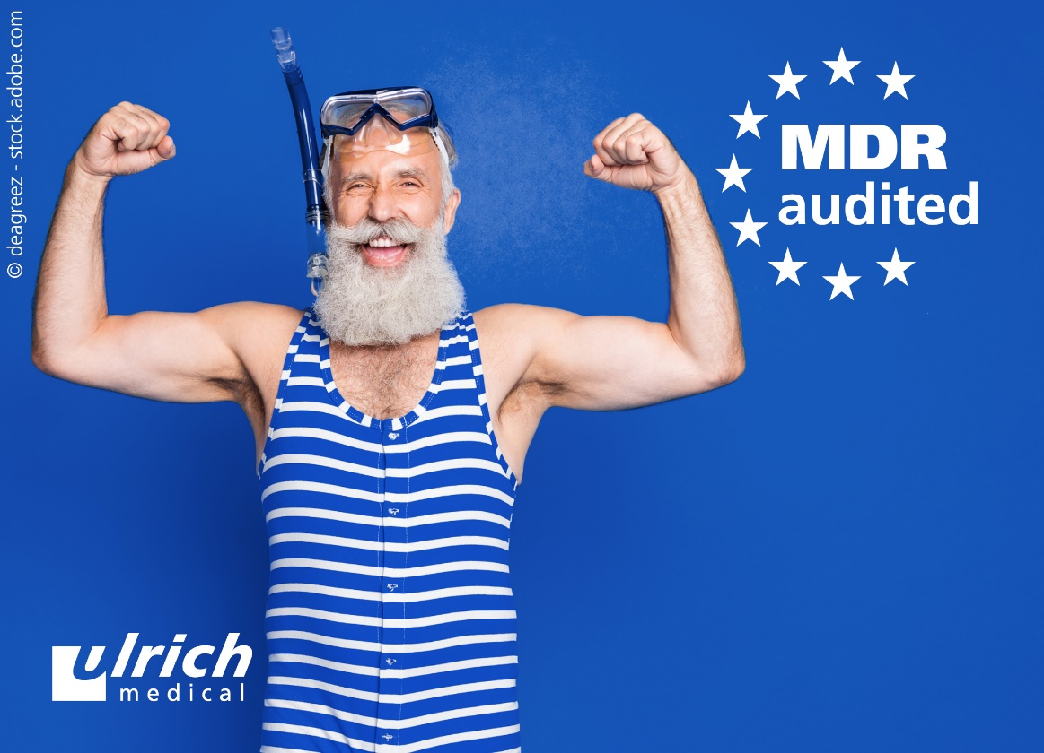
ulrich medical is one of the first German medical technology manufacturers to be successfully audited for the MDR.

Company data:
Name: ulrich GmbH & Co. KG
Brand: ulrich medical
Company structure: GmbH & Co. KG; independent, family-owned company, established in 1912
Industry: Medical engineering
Product range: Contrast media injectors, spinal systems, tourniquets
Company foundation: 1912 by Heinrich C. Ulrich
Managing partner: Christoph Ulrich
Managing director: Klaus Kiesel
Employees: approx. 400
Distribution: globally

Contact:
ulrich medical
Buchbrunnenweg 12, 89081 Ulm
Isabelle Korger
Tel.: +49 (0) 731 9654-103
E-mail: i.korger@ulrichmedical.com

Press/media contact:
Ruess Public T GmbH – Member of Ruess Group
Stefan Skrzipietz
Lindenspürstraße 22, 70176 Stuttgart
Tel.: +49 (0) 711/ 16446-17
www.ruess-group.com
E-mail: stefan.skrzipietz@ruess-group.com

Ulm, 01/20/2020

