Press Release

Shortage of skilled workers – ulrich medical banks on its own training

Ulm, July 2018. Like many other companies in the region, the internationally successful medical technology manufacturer ulrich medical in Ulm faces the challenge of finding highly skilled employees. Providing its own trainee programme is therefore an important element in the human resource strategy of the family-owned firm – a philosophy that goes back to the company’s founding 105 years ago and is now more crucial than ever.

At the beginning of September, ten trainees will embark on their careers with the help of experts in spinal implants and contrast-medium injectors. Having completed dual studies in business administration and healthcare management / healthcare industry and with a Bachelor’s degree in medical engineering based on the Ulm model, the trainees stand a good chance of being hired afterward as a toolmaker, machine tool mechanic, warehouse logistics specialist, IT specialist for system integration or business administrator for wholesale and foreign trade. The family-owned company has been training young people in technical and commercial professions to meet its own needs since it was founded in 1912. “A large part of our staff has been trained in-house or in cooperation with universities,” Christoph Ulrich, managing partner of ulrich medical says, highlighting the company’s approach.

Training with good prospects

“One of the guiding principles of ulrich medical has always been that sound training is the key to the future”. The company’s training programme was set up to give trainees the opportunity to develop, to be taken seriously and to acquire wide-ranging, practical knowledge and skills at a high level and later to be accepted as qualified experts in their field. “A hiring rate of 90 percent shows just how successful our approach has been,” says Anke Walkerling, HR Manager at ulrich medical. “For our strategy to continue to bear fruit in the future, we must anticipate the company’s needs early on. We therefore keep a close eye on developments in our industry and are also focussing increasingly on new and promising careers.”

Skilled staff for the future

In the 2019 training year, ulrich medical will be launching the new dual university degree programme in business administration / healthcare IT for the first time. The new programme at the Bad Mergentheim campus of Baden Wuerttemberg Cooperative State University Mosbach addresses the challenges placed on the healthcare system by digitization. The curriculum examines from various perspectives topics that are important for optimally integrating medical technology, information technology, business administration and specialist fields. The study programme takes three years to complete and leads to a Bachelor of Arts degree (B.A.).

In addition to trainee industrial mechanics, the company will also take on a trainee business administrator for marketing communication next year. Possible fields of work after completing training include classic advertising, dialogue marketing, events and public relations. Applications for 2019 are being accepted now. Interested candidates can find extensive information about training at ulrich medical on the company’s website at: https://www.ulrichmedical.de/karriere/ausbildung/.

Size: 3.292 characters (including spaces)

Photo: ulrich medical

-1-
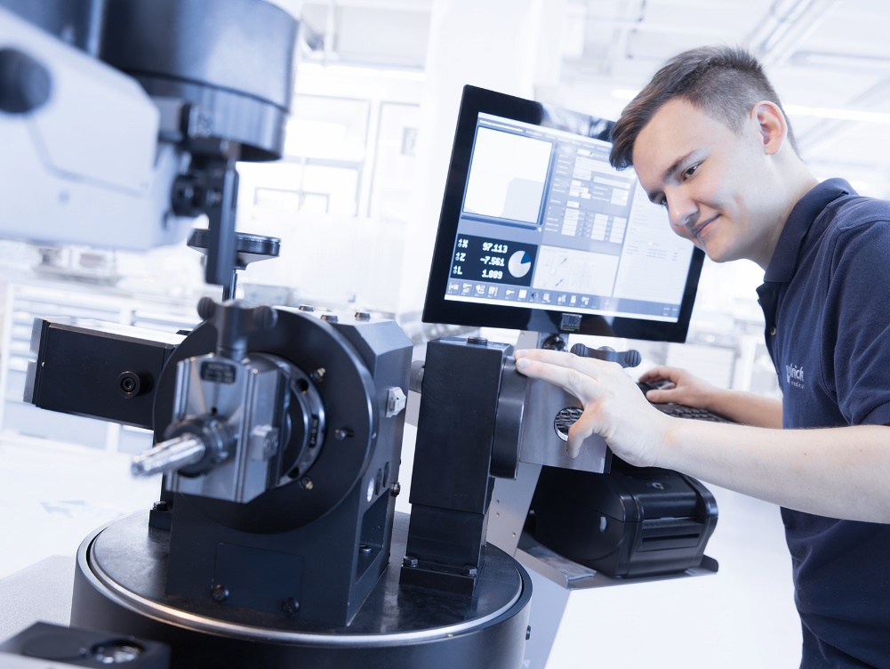

In addition to a training programme for industrial mechanics, a business administrator for marketing communication will start training for the first time next year.

About ulrich medical

Since its foundation as a family company in 1912, ulrich medical has developed, manufactured and distributed innovative medical technology products. Doctors and users worldwide trust in the more than 100 years of expertise. As one of the few companies in this sector, the Ulm-based company places great value in “Made in Germany” and develops and manufactures its products in Germany. ulrich medical specialises in two product categories: spinal systems and contrast-medium injectors. The Spinal Systems Division develops and produces implants made mostly of titanium and successfully markets them worldwide. They are used in cases of injury or disease affecting the entire spine. In the field of contrast media injectors for CT, MRI and angiography, ulrich medical supplies specially developed solutions that reliably support radiologists in the field of modern diagnostic imaging. Their user friendliness, outstanding quality and proven hygienic safety make them essential aids in routine clinical practice.

If you have any questions, please contact:
ulrich medical
Buchbrunnenweg 12, 89081 Ulm
Isabelle Korger
Tel.: 0731 9654-103
Email: i.korger@ulrichmedical.com

No fee is charged for offprints for editorial purposes. Confirmation requested.

